Angular 2 Setup Notes

# For Visual Studio framework 4.5

Assuming Node.js has been installed and the latest updates applied to VS.

We work on MVC Web Api style applications. Angular 2.0 is to be added to this type of app.

1. Create a New ASP.Net Web Application.
   1. I selected Web API as the template.
   2. I chose No Authentication.
   3. Once created run app to assure it works.
2. Go to <https://angular.io/docs/ts/latest/quickstart.html>
3. Right mouse click on the solution’s name, select add new item, and select NPM Configuration File. This will add the package.json file to your solution.

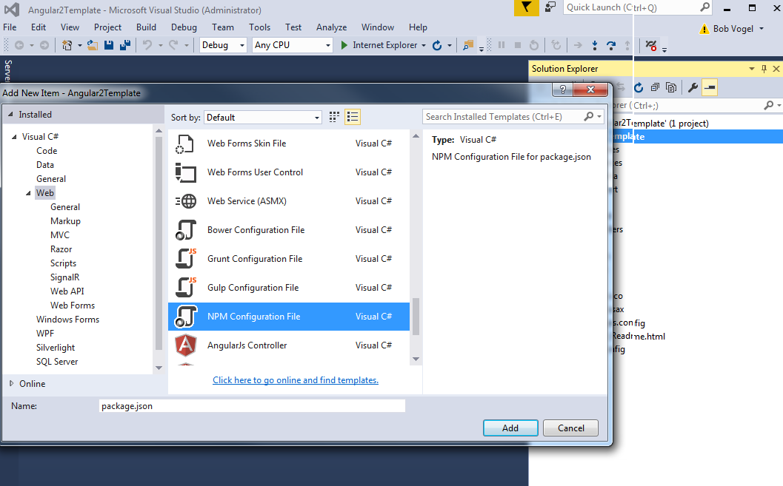

1. Next add the TypeScript JSON Configuration File to the solution.

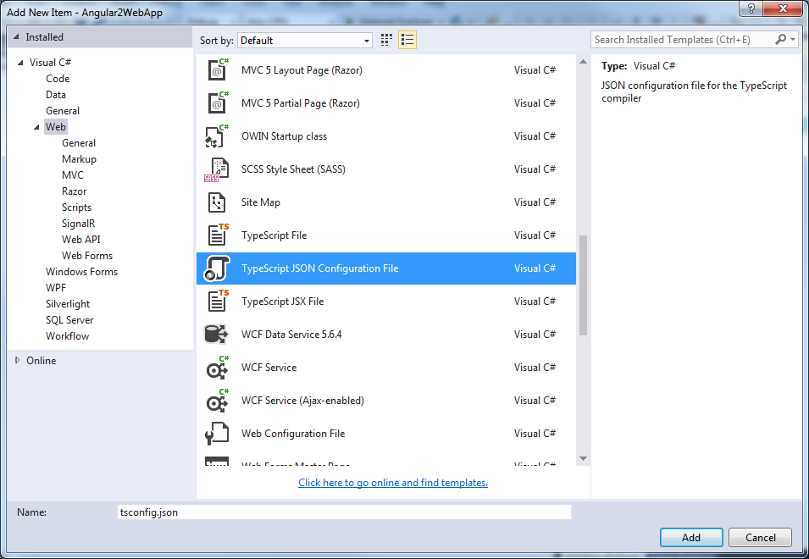

1. Then add a json file to the solution and name it typings.

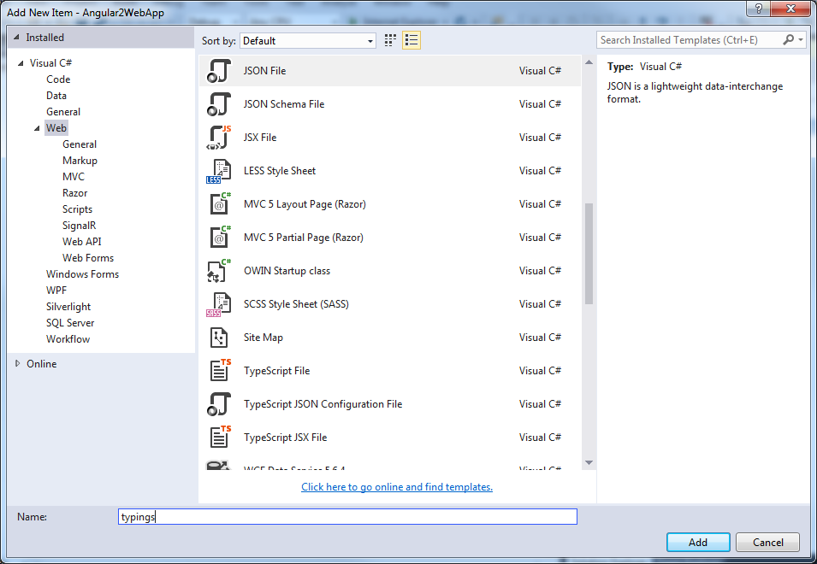

1. Add a Java Script File to the solution and name it systemjs.config.

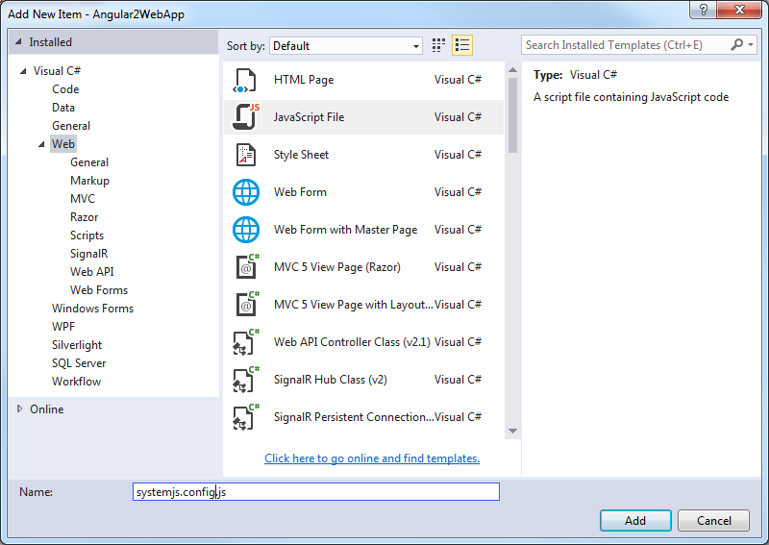

1. At this time your solution should look like this.

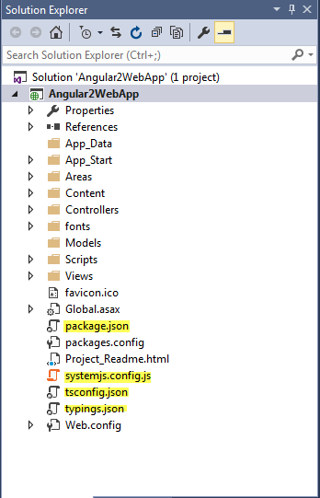

1. From the Angular Quick Start, Create configuration files section, copy the code for the following:
   1. Copy the package.json with no changes.
   2. Copy the tsconfig.json and then modify it to look like this:

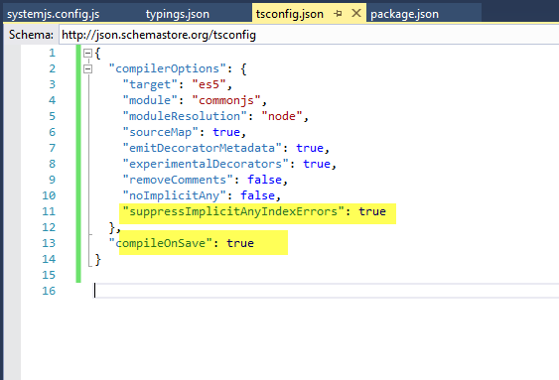

* 1. Copy the typings.json with no changes.
  2. Copy the systemjs.config.js with no changes.

1. Right mouse click on the package.json and select Restore Packages.
   1. This could take a minute.

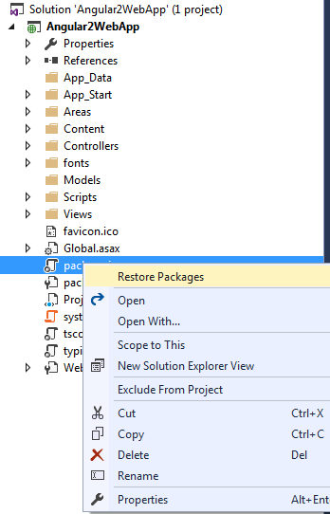

* 1. Once this is done you should see the following in the lower left corner of Visual Studio.



* 1. Also you can select show all files from the Solution Explorer and you should see the following:

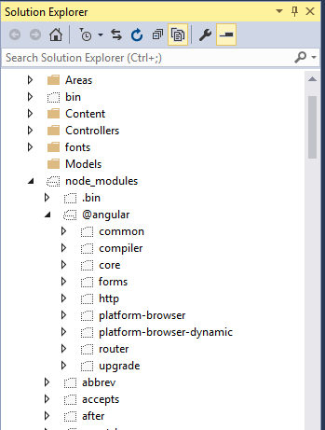

1. At the solution level add a new folder named app.
2. In the next step you will be adding TypeScript Files. If you get this prompt click NO.

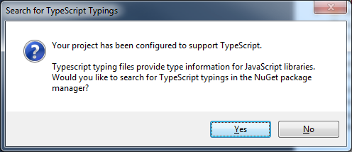

1. In the app folder add 3 TypeScript Files named:

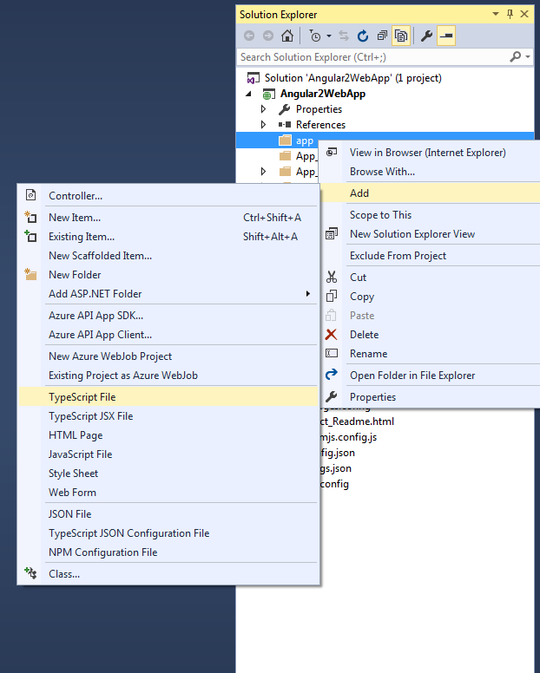

* 1. app.component.ts
  2. app.module.ts

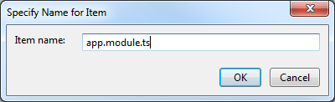

* 1. main.ts

1. For each file copy the code from the quick start.
2. Once you have copied the code into your solution make sure you save the files. The TypeScript files should compile down to js files on save. To see if this worked toggle the show all files in the solution explorer menu bar. You should see this:

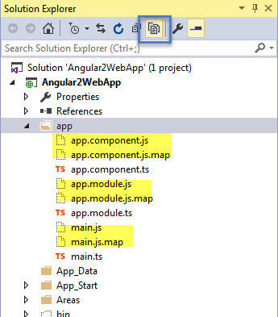

1. Now because we are implementing this into an MVC app we will modify the layout page and the “Home” index.cshtml. The following changes need to be implemented. Where is your choice.
2. The following code needs to be added in an html header. We chose to add this to the _Layout.cshtml.

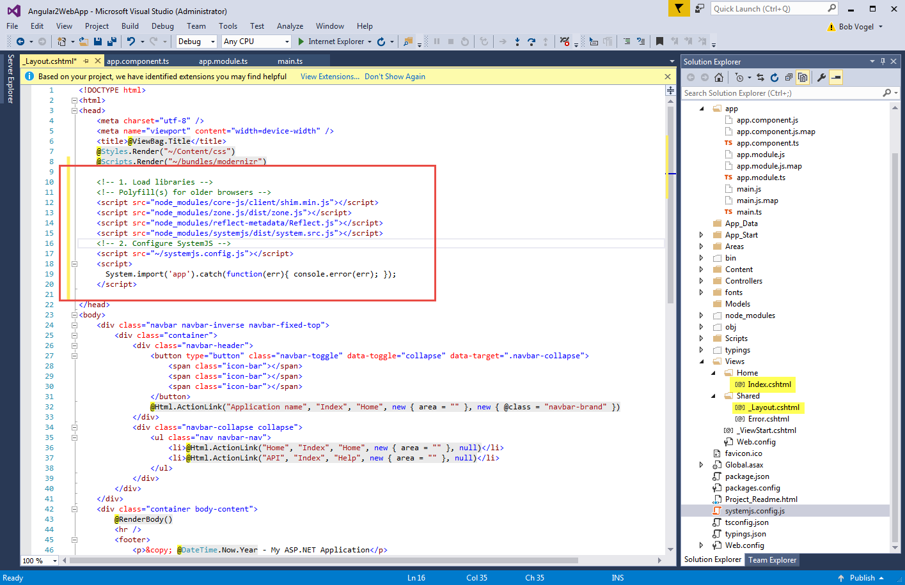

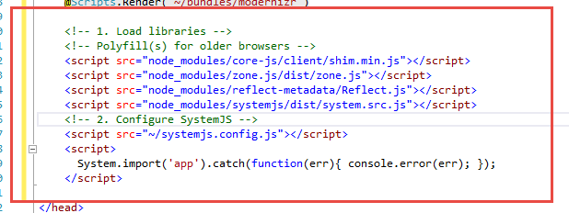

1. We then modified the Index.cshtml page as follows:

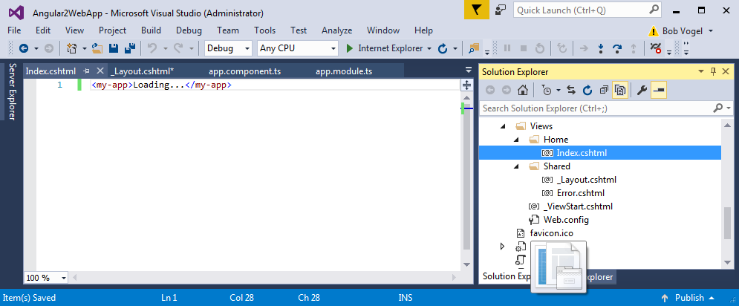

1. The first time I tried it I get a java script error regarding system.js. I was able to resolve this by dragging the systemjs.config.js file into the layout page and saving again. For some reason this did not work on the first try.
2. Save everything and when you run it hopefully you see something like this.

